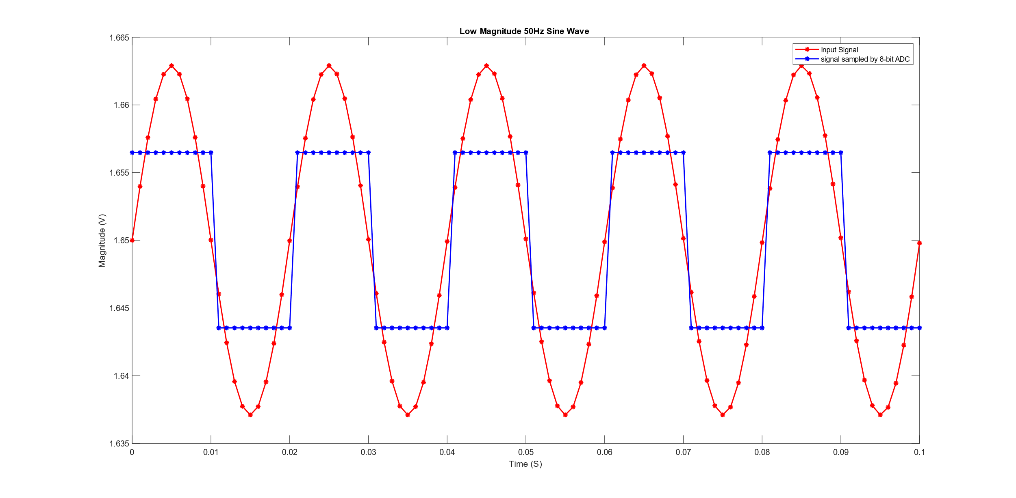

Figure 1. Effect of 8-bit resolution ADC on low magnitude signal

Figure 1 shows the effect of low resolution in capturing the low magnitude oscillations in the input signal. A sinusoidal signal clamped to 1.65 Volts, Having its peak amplitude as 1.65 ± 0.0129V. The original input signal is shown in red colour sampled at 1KHz, when it is sampled by an 8-bit ADC, having3.3V as VRef, the ADC cannot capture the signal correctly. The blue points in the plot shows the output of 8-bit ADC having 0.0129V (VRef/255 = 3.3V/255) as resolution. Figure 1 clearly shows the lower resolution ADC can not capture the low magnitude oscillations which is prevalent in some biomedical signal